**Section 2–7: Absolute Value Functions and Graphs**

**Introductions:**

Just as the absolute value of *x* it its distance from 0, the absolute value of $f(x)$, or $\left|f(x)\right|$, gives the distance from the line $y=0$ for each value of $f(x)$.

The simplest example of an **absolute value function** is $f\left(x\right)=\left|x\right|$. The graph of the absolute value of a linear function in two variables is V-shaped and symmetric about a vertical line called the **axis of symmetry**. Such a graph has either a single maximum point or a single minimum point, called the **vertex**.

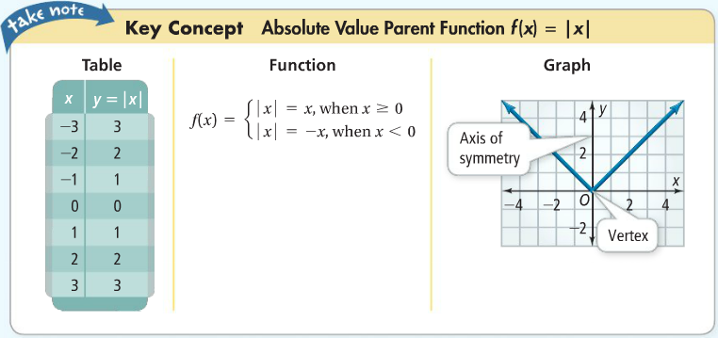

The transformations you studied in the last two lessons also apply to absolute value functions.

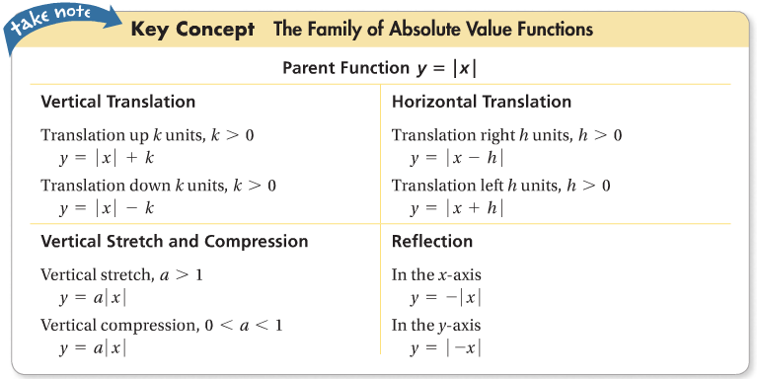

**Example 1: Graphing an Absolute Value Function**

What is the graph of the absolute value function $f(x)=\left|x\right|-4$? How is the graph different from the graph of the parent function $f\left(x\right)=\left|x\right|$?

|  |  |
| --- | --- |
| ***x*** | ***f*(*x*)** |
| –3 | –1 |
| –1 | –3 |
| **0** | –**4** |
| 1 | –3 |
| 3 | –1 |

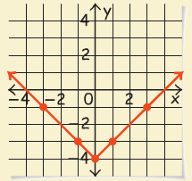

Step 1: make a table of values

Step 2: **\***determine where the vertex is

Step 3: graph the function

**\*** You can determine where the vertex is by looking at the table of values and see where the $f(x)$ values begin to turn.

**Example 2: Combining Translations**

For this function, $y=\left|x+2\right|+3$, identify the: (a) vertex, (b) axis of symmetry, and (c) transformation from the parent function $y=\left|x\right|$.

1. the vertex of this function is $(-2, 3)$
2. the axis of symmetry is $x=-2$; the value is the same as the *x*-value from the vertex
3. the parent function $y=\left|x\right|$ is **translated left 2 units and up 3 units**.

**Vertical Stretch and Compression:**

The right branch of the graph of $y=\left|x\right|$ has a slope of 1. The graph of $y=a\left|x\right|$, $a>0$, is a stretch or compression of the graph of $y=\left|x\right|$. Its right branch has a slope of $a$. The graph of $y=-a\left|x\right|$ is a reflection of $y=a\left|x\right|$ in the *x*-axis and its right branch has a slope of $–a$.

**Example 3: Vertical Stretch and Compression**

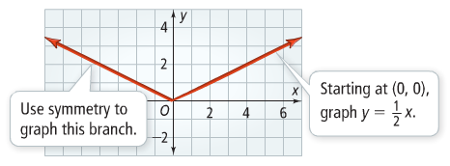What is the graph of $y=\frac{1}{2}\left|x\right|$?

The graph is a vertical compression of the graph of $f\left(x\right)=\left|x\right|$ by the factor of $\frac{1}{2}$. Graph the right branch and use symmetry to graph the left branch.

You can combine the equations for stretches and compressions with the equations for translation to write a general form for absolute value functions.

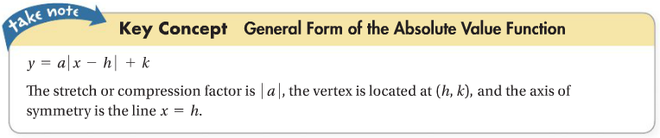

**Example 4: Writing an Absolute Value Function**

What is the equation of the absolute value function?

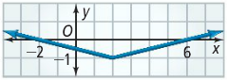

**Step 1: Identify the vertex.**

The vertex is at $(2, -1)$, so $h=2$ and $k=-1$.

**Step 2: Identify $a$.**

The slope of the branch to the right of the vertex is $\frac{1}{4}$, so $a=\frac{1}{4}$.

**Step 3: Write the equation.**

**Substitute the values of $a$, $h$, and $k$ into the general form $y=a\left|x-h\right|+k$.**

The equation that describes the graph is $y=\frac{1}{4}\left|x-2\right|-1$.